**TABLES:**

1. Hotel

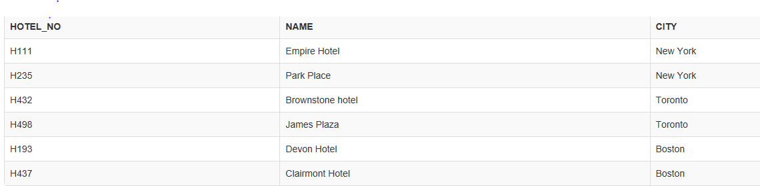

1. Room

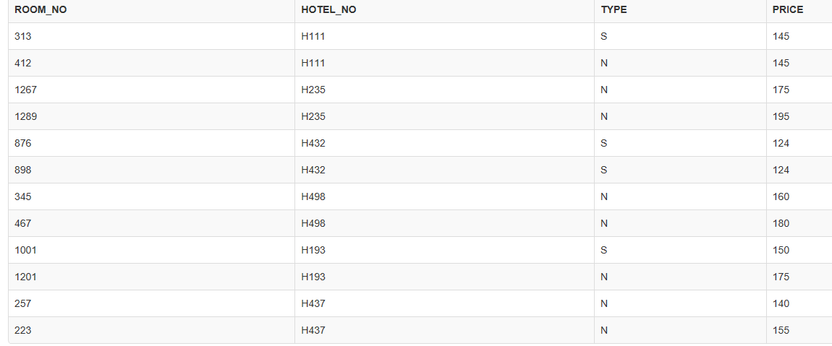

1. Guest

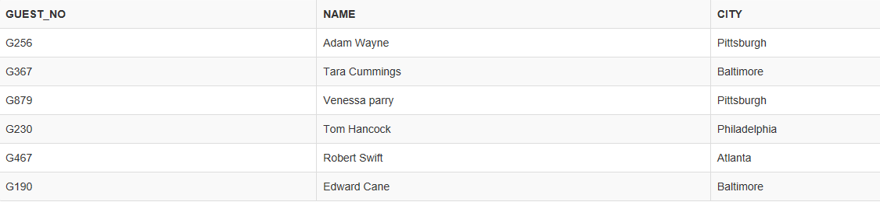

1. Booking

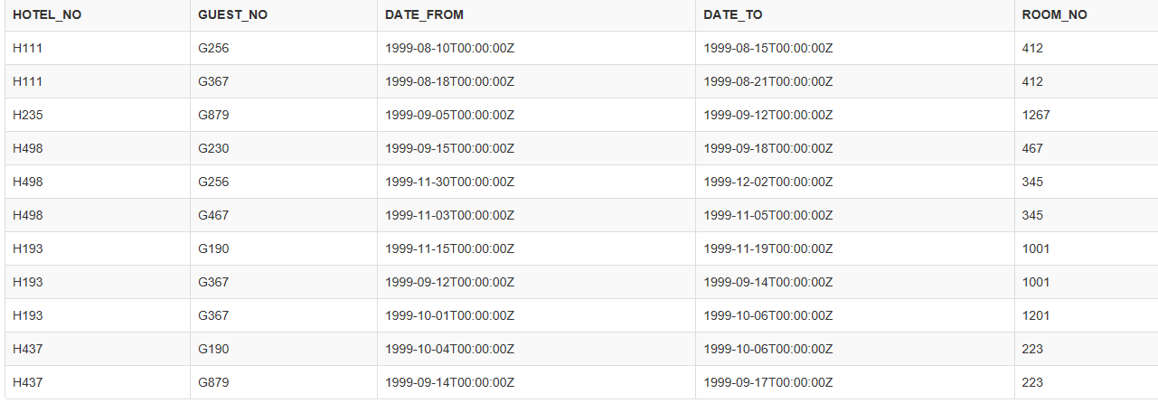

**Query Resultsets:**

1.List full details of all hotels.

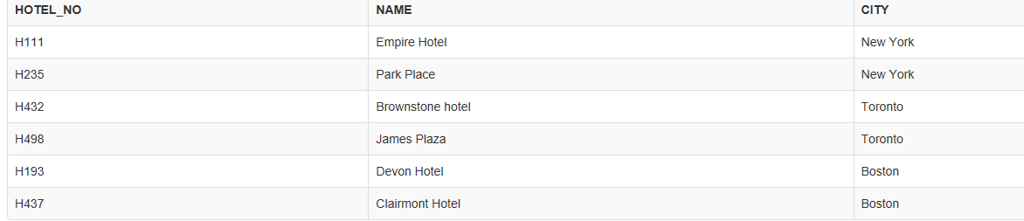

2. List full details of all hotels in New York.



3. List the names and cities of all guests, ordered according to their cities.

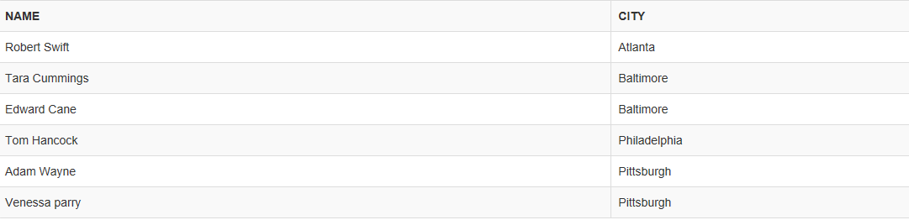

4. List all details for non-smoking rooms in ascending order of price.

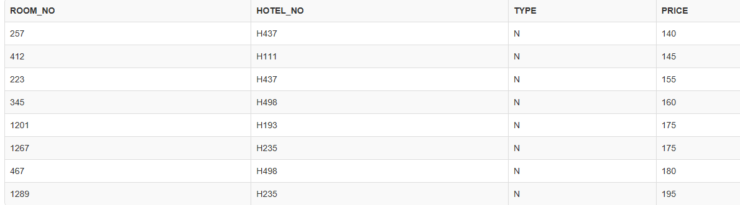

5. List the number of hotels there are.

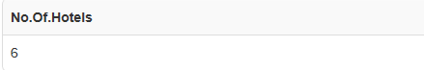

6. List the cities in which guests live. Each city should be listed only once.

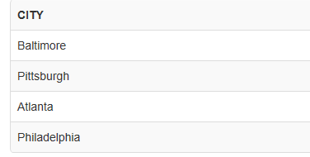

7. List the average price of a room.

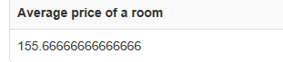

8. List hotel names, their room numbers, and the type of that room.

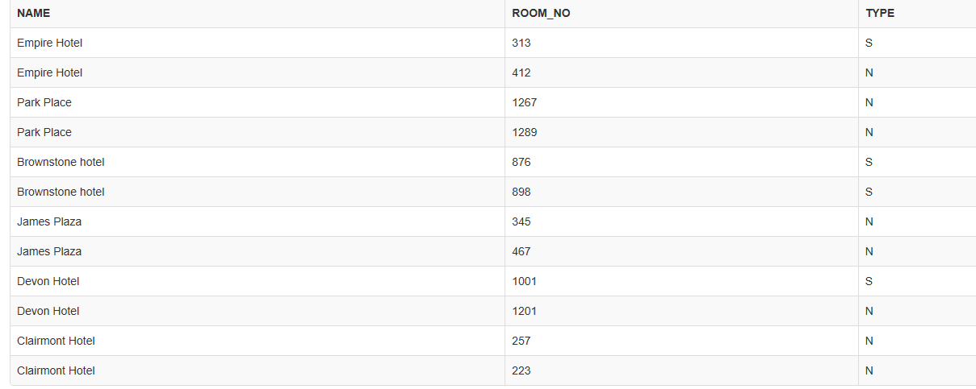

9. List the hotel names, booking dates, and room numbers for all hotels in New York.

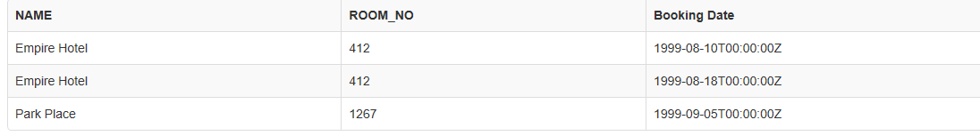

10. What is the number of bookings that started in the month of September?

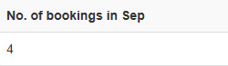

11. List the names and cities of guests who began a stay in New York in August.



12. List the hotel names and room numbers of any hotel rooms that have not been booked.



13. List the hotel name and city of the hotel with the highest priced room.

14. List hotel names, room numbers, cities, and prices for hotels that have rooms with prices lower than the lowest priced room in a Boston hotel.



15. List the average price of a room grouped by city.

